Case 6-Afr-Nigeria-Yoruba-Deity-Veicular Andesite-Prehistoric

**Nigeria: Extremely rare and old, tribally-used Yoruba stone-head figure. Size: 21x11 cm.**

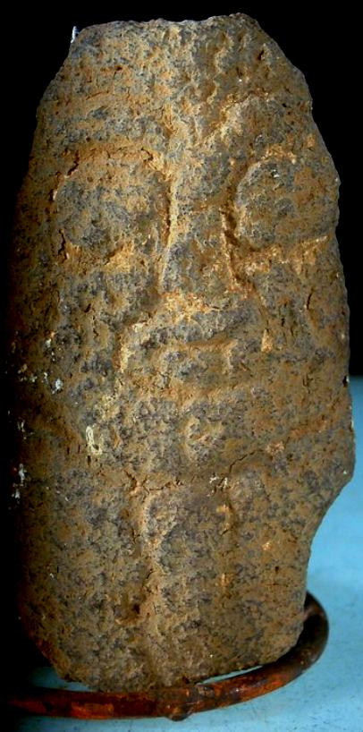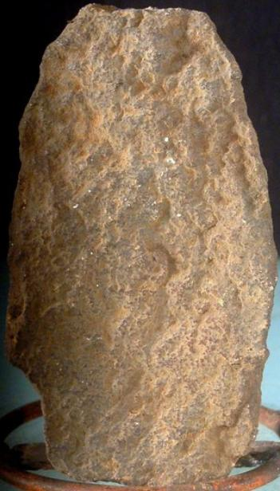The Yoruba gods form a true pantheon; the creator god, Olodumare, reigns over almost four hundred *orisha* (deities) and nature spirits who live among the rocks, trees, and rivers.

Shango (also Sango and Sagoe), the deity of thunder and lightning is represented in the historic period by figures carved from wood which are kept in shrines. However, this figure is a prehistoric version of the Shango figure and was carved from rock. It has the iconographically correct protruding eyes that are found on human figures as well as the flat, protruding, parallel lips. Although within the basic canon of Yoruba sculpture many local styles can be distinguished down to the hand of the individual artist, this prehistoric example is possibly unique.

Another Yoruba stone head which is more three-dimensional and by appearances later than the present example was offered by the Barakat Gallery of Beverly Hills, CA, for 6,000 USD in 2013, and it is pictured below. Note that it also has the same iconography of facial features. Therefore, the above example is a crucial and unique specimen in the development of Yoruba sculptural iconography and technique.

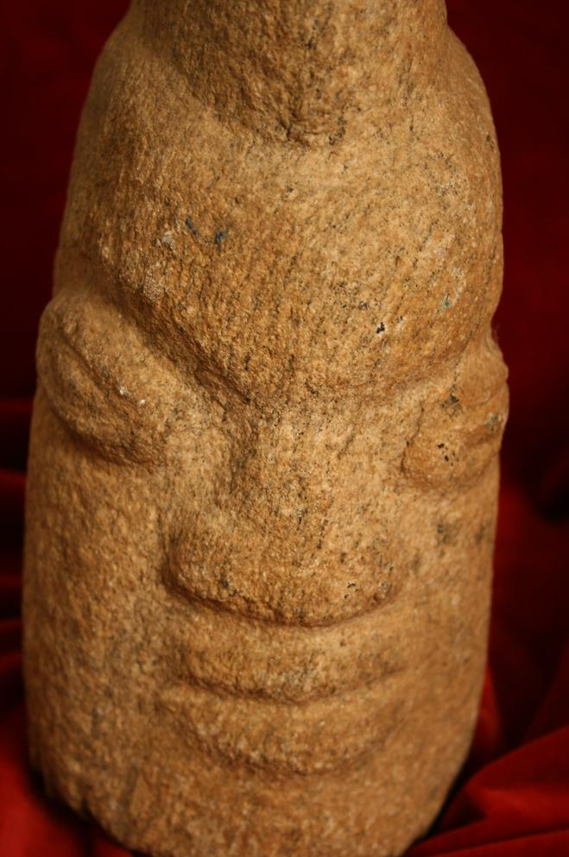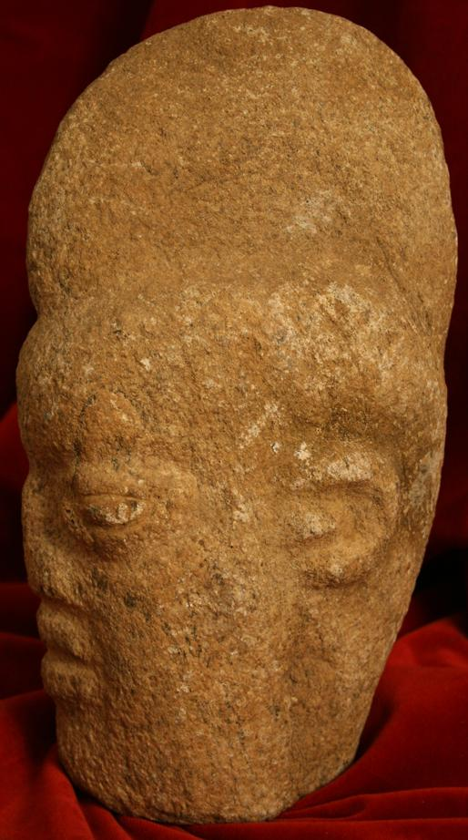

yoruba Stone Head - fj.7700dc  
**Origin:** Yoruba/ Nigeria/ Africa  
**Circa:** 1600 AD to 1900 AD   
**Collection:** Barakat Gallery, African Art. $6,000.00, 27 Feb. 2013  
**Location:** 421 North Rodeo Drive, Beverly Hills, CA 90210, phone: 310-859-8408

*Other cults abound among the Yoruba. Among these are the following.*

The *Gelede* cult pays homage to the power of elderly women. During *Gelede* festivities, helmet masks carved in the form of a human face are worn. On top of the head there is either an elaborate coiffure

The *Epa* cult, which is connected with both the ancestors and agriculture, vary enormously according to the town in which they appear. The mask proper, roughly globular, has highly stylized features that vary little; but the superstructure, which may be four feet or more in height, is often of very great complexity. Generally, they are worn during funerals or rites of passage ceremonies and characteristically they are composed of many elements – usually a human-face helmet mask topped by an elaborate standing figure. When not worn, these masks are kept in shrines where they are honored with libations and prayers.

The *Ogboni* cult has brass figures, called *Edan*, that are cast in pairs and attached to spikes and a chain runs from head to head to join the pair. They are worn over the shoulders of Ogboni members as sign of office or as an amulet.

*Ile*, the earth Goddess, is represented by large brass figures, called *onile*, carved as a pair and represent the male and female aspects of t5he earth.

The *Ibeji* cult of twins is devoted to mothers of twins, which among the Yoruba is unusually frequent. An *ibeji* statuette is to be made, if one twin died; this *ibeji* remainswith the surviving twin and is treated, fed, and washed as a living child. Their effigies, made on the instructions of the oracle, are among the most numerous of all classes of Yoruba sculpture.

Equestrian figures are3 a common theme in Yoruba wood and brass sculpture. **It reflects the importance of the cavalry in the campaigns of the kings who created the Oyo Empire as early as the sixteenth through the eighteenth centuries. Only Yoruba chiefs and their personal retainers were privileged to use the horse. Nevertheless, the rider and the horse remained an important social symbol and offered an exciting subject for artistic imagination and skill.** The diminutive animal and the dwarfish legs of the horseman are typical for this type of figures.

Carved doors and house posts with mythic themes are found in shrines and palaces and in the houses of important men.

The Yoruba people, numbering over 12 million, are the largest nation in Africa with an art-producing tradition. Most of them live in southwest Nigeria, with considerable communities further west in the Republic of Benin and in Togo. They are divided into approximately twenty separate subgroups, which were traditionally autonomous kingdoms. Excavation at Ife of life-sized bronze and terracotta heads and full-length figures of royalty and their attendants have startled the world, surpassing in their portrait-like naturalism everything previously known from Africa. The cultural and artistic roots of the Ife masters of the Classical Period (ca. 1050—1500) lie in the more ancient cultural center of Nok to the northeast, though the precise nature of this link remains obscure.

Now two-third of the Yoruba are farmers. Even if they live in the city, they keep a hut close to the fields; they grow corn, beans, cassava, yams, peanuts, coffee, and bananas. It is they who control the markets -- along with the merchants and artisans: blacksmiths, copper workers, embroiderers, and wood sculptors, trades handed down from generation to generation.

# 

# 

# 

